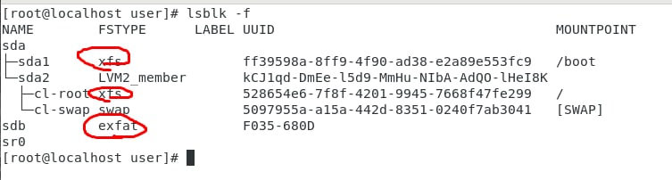

The usb drive type

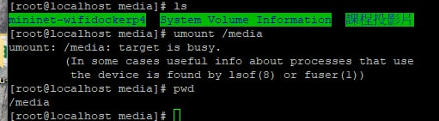

The data stored inside the usb drive

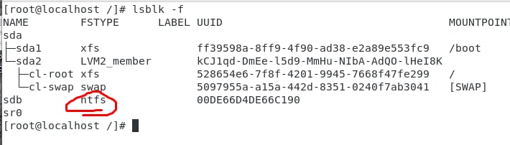

yum install epel-release -y

yum install ntfs-3g -y

Echo ~+

:use to know the location you are at currently

Echo ~-

:echo command in linux is used **to display line of text/string that are passed as an argument** This is a built in command that is mostly used in shell scripts and batch files to output status text to the screen or a file.

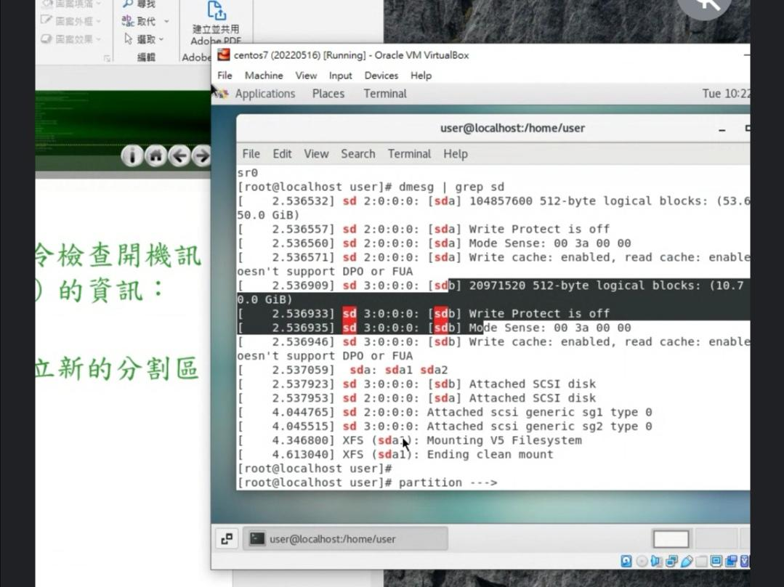

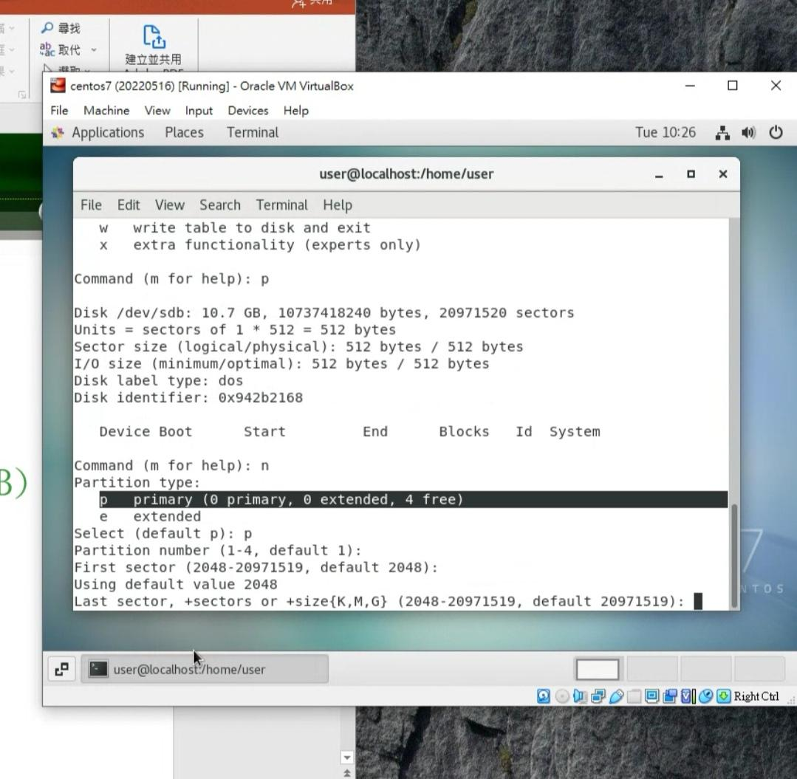

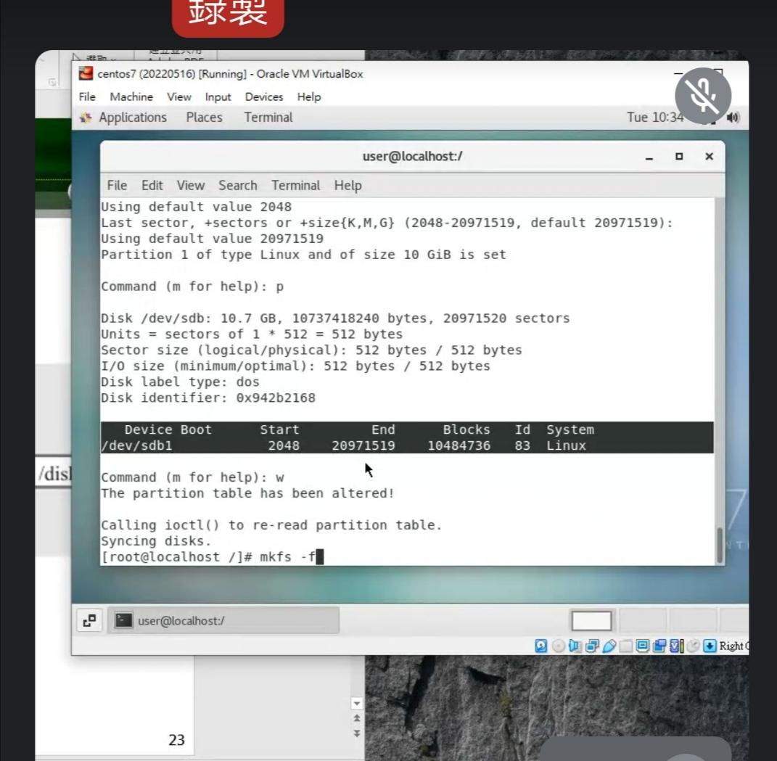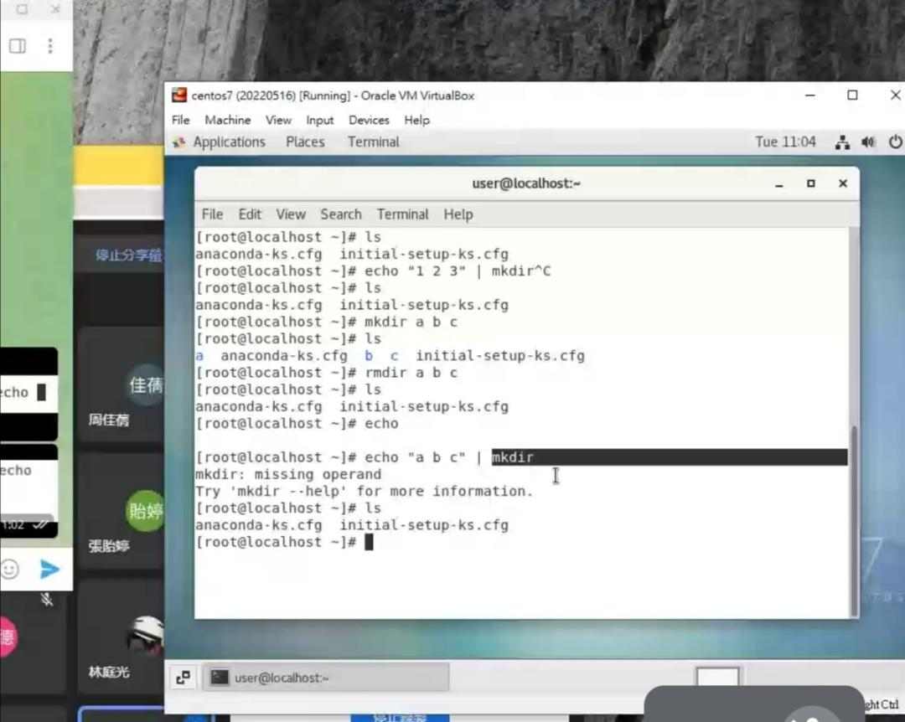

Unable to put "a b c"

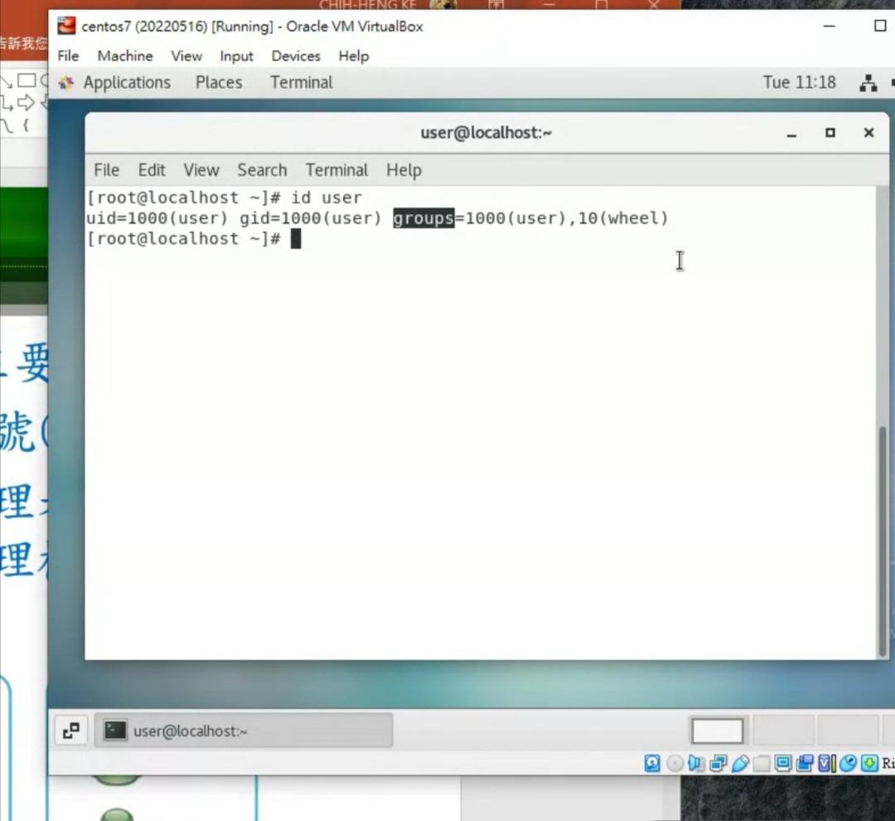

:gid join group 1000 and 10

One user can belong to many groups

Wheel (this user can change to super user)

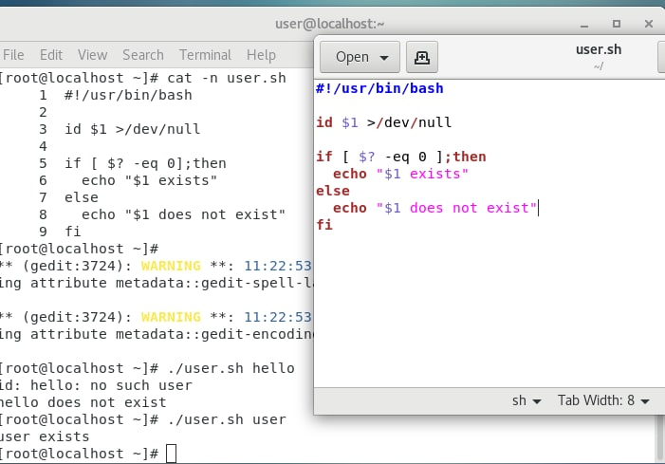

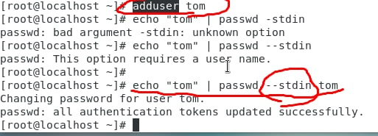

adduser

//allow to add a new user

echo “tom” | passwd - - stdin tom

//set the password for user tom, with password “tom”

Usermod [options] [username]

//use to update the user information

/etc/passwd – information regarding users’ accounts

/etc/shadow – user security-related information

/etc/group – information about groups

/etc/gshadow – group security-related information

/etc/login.defs – shadow password suite configuration

Userdel [username]

//use to immediately delete a user

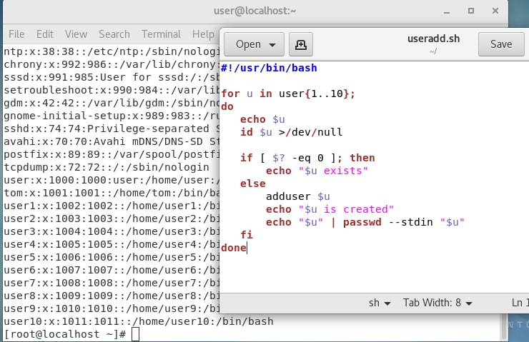

in centos system, uid < 1000 (system account), >=1000 (normal user account)

system account (nologin) , user account (bash)c

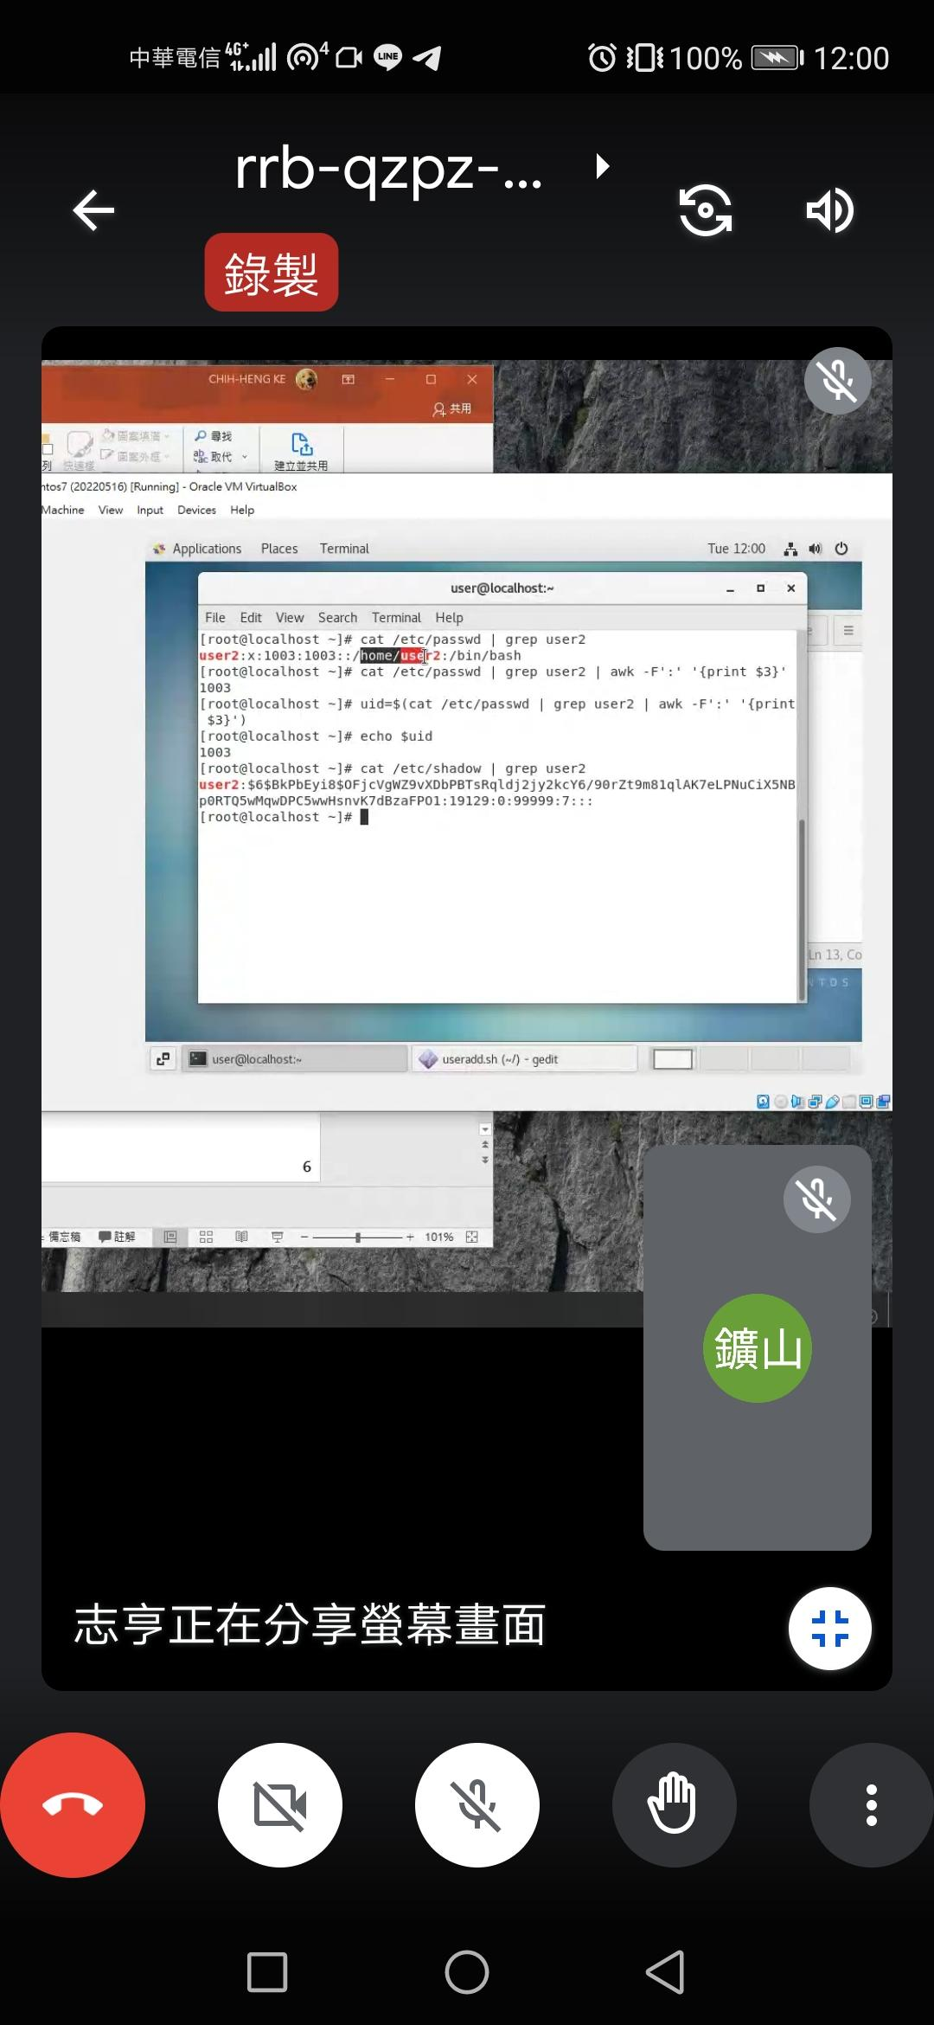

**DevOps (Development + Operations)**